In-Line Polarizer

1 Features
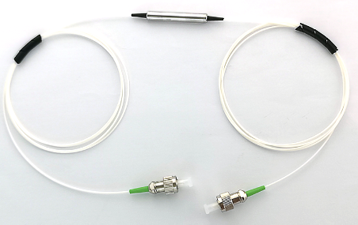
- Low Insertion Loss
- High Extinction Ratio & High Isolation
- High stability and reliability
- Telcordia Compliant
- RoHS Compliant

2 Applications
- Fiber Optical Instrument
- Fiber Sensor

3 Specifications
Parameters | Unit | Value
Operating Wavelength | nm | 1310, 1550 | 1064 | 980 | 850
Bandwidth | nm | ±50 | ±30 | ±10 | ±10
Typ. Insertion Loss @23℃ | dB | 0.30 | 0.40 | 0.7 | 0.8
Insertion Loss @ 23℃ | dB | ≤0.5 | ≤0.6 | ≤0.9 | ≤1.0
Typ. Extinction Ratio@ 23℃ | dB | 30 | 30 | 28 | 28
Extinction Ratio @23℃ | dB | ≥28 | ≥28 | ≥25 | ≥25
Fiber Type | / | PM1310or1550  SMF-28e | PM980  HI1060 | PM980  HI1060 | PM850  SM800
Return loss | dB | ≥50
Power handling | mW | ≤300
Fiber Length | m | 1.0 ±0.05
Connector | / | FC/APC
Operating temperature | ℃ | -5~+70
Storage temperature | ℃ | -40 ~ +80
Dimensions | mm | Ф5.5*L35
Above specifications are for devices without connectors.
For device with connector, IL is 0.3dB higher, RL is 5dB lower, ER is 2dB lower.
The default connector key is aligned to slow axis.

4 Mechanical Dimensions
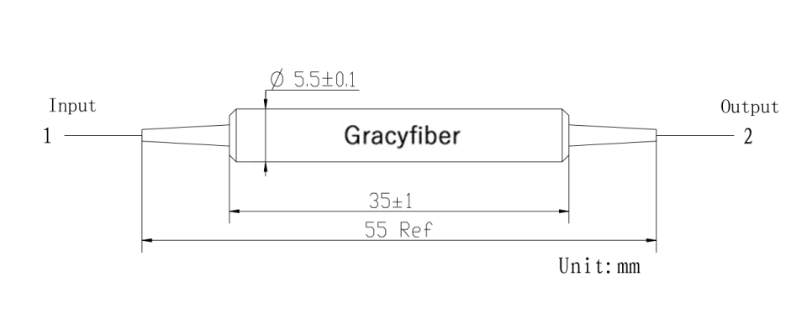

5 Ordering information
ILP | - | X | XX | X | X | XX | XX | XX | X | X
 |  | Operating Wavelength | Package  Type | Input  Type | Output  Type | Fiber  Type | Fiber  Length | Pigtail Type | Input  Connector | Output  Connector
ILP |  | 85=PM850 | ST=Φ5.5×L35 | 1= SMF-28e | 1= SMF-28e | 02=250um  fiber | 10=1.0m | 02=250um fiber | 0=No | 0=No
 |  | 98=PM980 | XX= Customized | 2= PM1310 | 2= PM1310 | 09=0.9m tube |  | 09=900um loose tube | 1=FC/UPC | 1=FC/UPC
 |  | 10=PM1060 |  | 3= PM1550 | 3= PM1550 | NA=No Tube |  |  | 2=FC/APC | 2=FC/APC
 |  | 31=PM1310 |  | 4= PM980 | 4= PM980 |  |  |  | 3=SC/UPC | 3=SC/UPC
 |  | 55=PM1550 |  | 5= HI1060 | 5= HI1060 |  |  |  | 4=SC/APC | 4=SC/APC
 |  |  |  | 6= PM850 | 6= PM850 |  |  |  | 5=LC/UPC | 5=LC/UPC
 |  |  |  | 7= SM800 | 7= SM800 |  |  |  | 6=LC/APC | 6=LC/APC

Part Number | Product Description
ILP-55ST330910-22 | In-Line Polarizer Device，PM1550nm（Panda）Input&Output fiber is PM1550fiber,  0.9mm Hytrel White tube(length is 1.0m)With FC/APC Connetor（connector key is aligned to slow axis）

